Western artists count on Stampede show
By Eric Volmers, Calgary Herald July 10, 2013
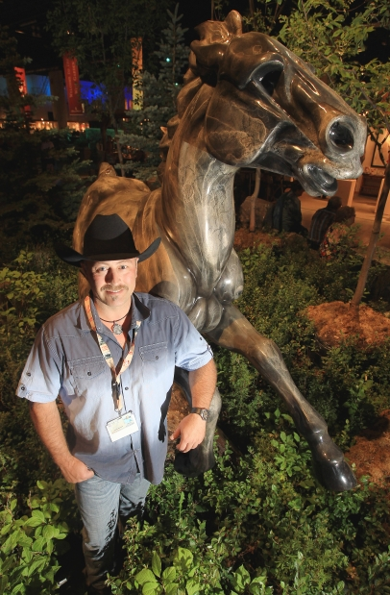
It stands on guard a few feet away from Jason Napier’s booth at the Stampede’s Western Oasis.
The life-size horse, titled Stir’d UP, is 450 kilograms worth of bronze that presents six months of work for Napier, a Washington State artist selling his wares this week at the Calgary Stampede’s Western Showcase.
Finished with a black and silver granite-like patina, Stir’d UP captures a “boundless horse running at top speed,” Stir’d UP is based on a smaller bronze piece that Napier made a few years back. It’s a testament to the sort of topics that Western art aficionados admire: action, horses, tradition.
Perhaps more importantly for Napier and the 60 other artists at the Western Oasis this year, it’s also a testament to the fact that many of said aficionados have plenty of money to spend.
This particular piece is not for sale. It was commissioned by John Simpson, CEO of Calgary’s CANA Construction and a one-time member of the Canadian Equestrian Team who competed in the 1976 Olympics.
“He called me back in December and said ‘Jason I want you do a life-size for me, but on one condition: you have to have it done by the Calgary Stampede,’” says the amiable Napier with a grin. “I said ‘I’ll do it.’ There was a lot of 18-hour days on that one.”
In the Western Oasis, located at the BMO Centre, Stir’d UP is not far from an elegantly designed wine bar. The air-conditioned halls, filled with every sort of western art imaginable, seem a coolly cultured counterpoint to the Stampede’s normal esthetic of rough-and-ready cowboys, crowded midways and deep-fried everything.
This is not to say you have to possess a CEO-level salary to appreciate western art. But for many of the artists who pass the competitive jury process to make it into the show each year, the Stampede represents a once-a-year opportunity for a big payday and to further their relationships with many of the well-heeled collectors of western art.
This is the second Stampede for Napier, who lives in Friday Harbor in the Washington State’s San Juan Islands. While he was bit under the gun to get Stir’d UP ready on time, he still managed to create a number of new pieces for the show, which range in price from $1,500 to $100,000. “I had never really done a show up here in Canada and I thought this would be a great opportunity,” said Napier, who was awarded this year’s artist’s choice honours by his fellow artists. “I have a lot of customers from Calgary. They have second homes in Arizona and California. So I do some shows down in that area.”

So, needless to say, when massive flooding hit Calgary and drenched the Stampede grounds, there were plenty of frayed nerves over the possibility that the Greatest Outdoor Show on Earth would not happen this year.
“It’s a major show for a lot of artists,” says Georgia Desmarais, who is on the Stampede’s public art committee. “It’s really, truly, one of the only western art shows in Canada — a large western art show with 60 artists. So it truly is a very important show for people and it’s hard to get in. It would have been devastating, in so many ways, to not have had this show.”
Henri de Groot, an Entwistle artist who works in graphite and oil to reveal “a glimpse of a real life cowboy or rancher,” has been coming for 22 years.
Had the Stampede, and the art showcase specifically, been cancelled, it would have had a major impact on his year.
“It would have been a disaster for everybody,” de Groot says. “This is really important for me. I work for six months on this show. So this is six months of my work.”As with many artists, de Groot takes great pains to present a number of new works every year.
“It’s always nice to get new customers,” says de Groot. “Eventually, (with collectors) a house is full and they don’t need anymore. It’s just common sense.”
Still, most of those who purchase are serious collectors.
“All of the art in this room is too expensive to be just a frivolous (purchase),” he said. “For the big-ticket items, it’s pretty big money.”
© Copyright (c) The Calgary Herald

